Harini G
192524011
LOGICAL, BIT-MANIPULATION AND SHIFT OPERATIONS
USING 8085 MICROPROCESSOR
a. PROGRAM A – 8-BIT LOGICAL AND MASKING OPERATIONS
Aim: To write and execute an 8085 assembly language program to perform AND, OR, XOR, complement and masking operations on 8-bit data.
Apparatus Required:
- 8085 microprocessor simulator
- Computer system
Input:
- X = A7H stored at memory location 4500H
- Y = 3CH stored at memory location 4501H
Algorithm:
- Load the first 8-bit data into the accumulator.
- Perform AND, OR and XOR operations with the second data.
- Perform the complement operation on the first data.
- Apply a mask to extract the lower nibble.
- Store each result in the specified memory location.
- Stop the program.
Program:
LDA 4500H
MOV B A
LDA 4501H
ANA B
STA 4502H
LDA 4500H
MOV B A
LDA 4501H
ORA B
STA 4503H
LDA 4500H
MOV B A
LDA 4501H
XRA B
STA 4504H
LDA 4500H
CMA
STA 4505H
LDA 4500H
ANI 0FH
STA 4506H
HLT
Input and Output:
Memory location | Data
4500H | A7H
4501H | 3CH
4502H – AND result | 24H
4503H – OR result | BFH
4504H – XOR result | 9BH
4505H – Complement | 58H
4506H – Lower nibble | 07H
Result: Thus, the 8-bit logical and masking operations were performed successfully using the 8085 microprocessor.

Input: X = A7H at 4500H, Y = 3CH at 4501H.
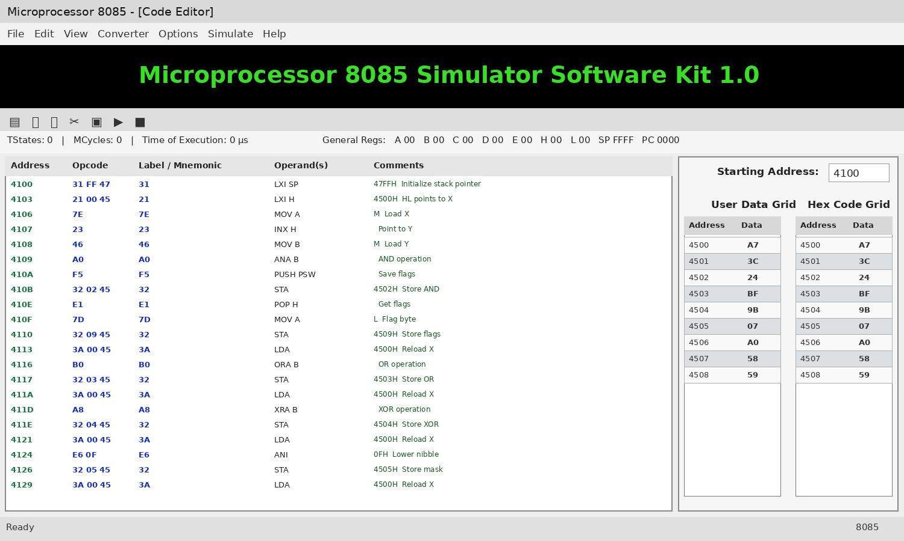
8085 simulator-style screenshot illustration

b. PROGRAM A – 16-BIT ONE’S AND TWO’S COMPLEMENT
Aim: To write and execute an 8085 assembly language program to find the one’s complement and two’s complement of a 16-bit number.
Apparatus Required:
- 8085 microprocessor simulator
- Computer system
Input:
- 16-bit number W = 1234H
- Lower byte = 34H at 450AH
- Higher byte = 12H at 450BH
Algorithm:
- Load the lower byte of the 16-bit number.
- Complement the lower byte and store the result.
- Complement the higher byte and store the result.
- Add 1 to the complemented lower byte.
- If a carry occurs, increment the complemented higher byte.
- Store the two’s complement result and stop the program.
Program:
LDA 450AH
CMA
STA 450CH
LDA 450BH
CMA
STA 450DH
LDA 450AH
CMA
ADI 01H
STA 450EH
JNC SKIP
LDA 450BH
CMA
INR A
STA 450FH
JMP STOP
SKIP: LDA 450BH
CMA
STA 450FH
STOP: HLT
Input and Output:
Memory location | Data
450AH | 34H
450BH | 12H
450CH – One’s complement (low) | CBH
450DH – One’s complement (high) | EDH
450EH – Two’s complement (low) | CCH
450FH – Two’s complement (high) | EDH
Result: Thus, the one’s complement and two’s complement of the given 16-bit number were obtained successfully.

Input: W = 1234H (34H at 450AH, 12H at 450BH).
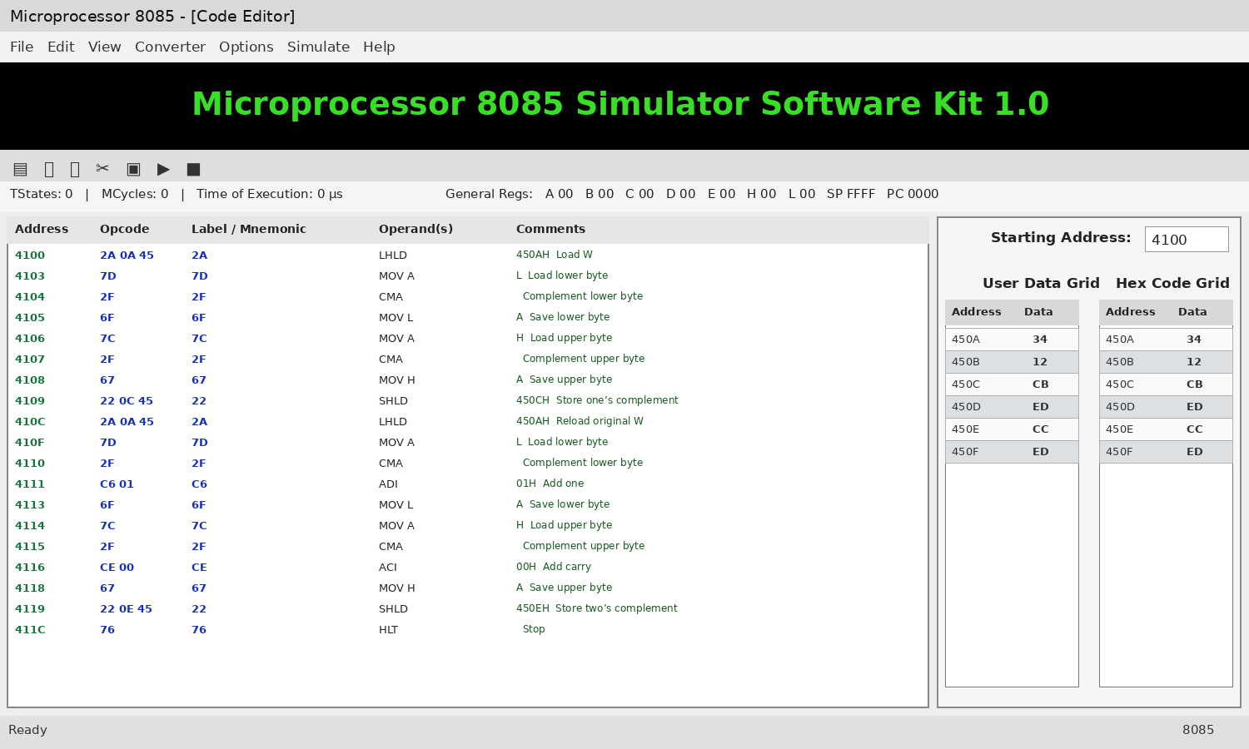
8085 simulator-style screenshot illustration

c. PROGRAM B – 8-BIT BIT SETTING, CLEARING, ROTATE AND SHIFT
Aim: To write and execute an 8085 assembly language program to perform bit setting, bit clearing, rotation and shift operations on an 8-bit number.
Apparatus Required:
- 8085 microprocessor simulator
- Computer system
Input:
- Data D = CAH stored at memory location 4510H
Algorithm:
- Load the given 8-bit data into the accumulator.
- Set bit 0 using the OR operation.
- Clear bit 3 using the AND operation with a mask.
- Perform left and right rotate operations.
- Perform left and right shift operations.
- Store the results in memory and stop the program.
Program:

LDA 4510H
ORI 01H
STA 4511H

LDA 4510H
ANI F7H
STA 4512H

LDA 4510H
RLC
STA 4513H

LDA 4510H
RRC
STA 4514H

LDA 4510H
ADD A
STA 4515H

LDA 4510H
STC
CMC
RAR
STA 4516H

HLT
Input and Output:
Memory location | Operation | Result
4510H | Input data | CAH
4511H | Set bit 0 | CBH
4512H | Clear bit 3 | C2H
4513H | Rotate left | 95H
4514H | Rotate right | 65H
4515H | Shift left | 94H
4516H | Shift right | 65H
Result: Thus, bit setting, bit clearing, rotation and shift operations were performed successfully using the 8085 microprocessor.

Input: D = CAH at 4510H.
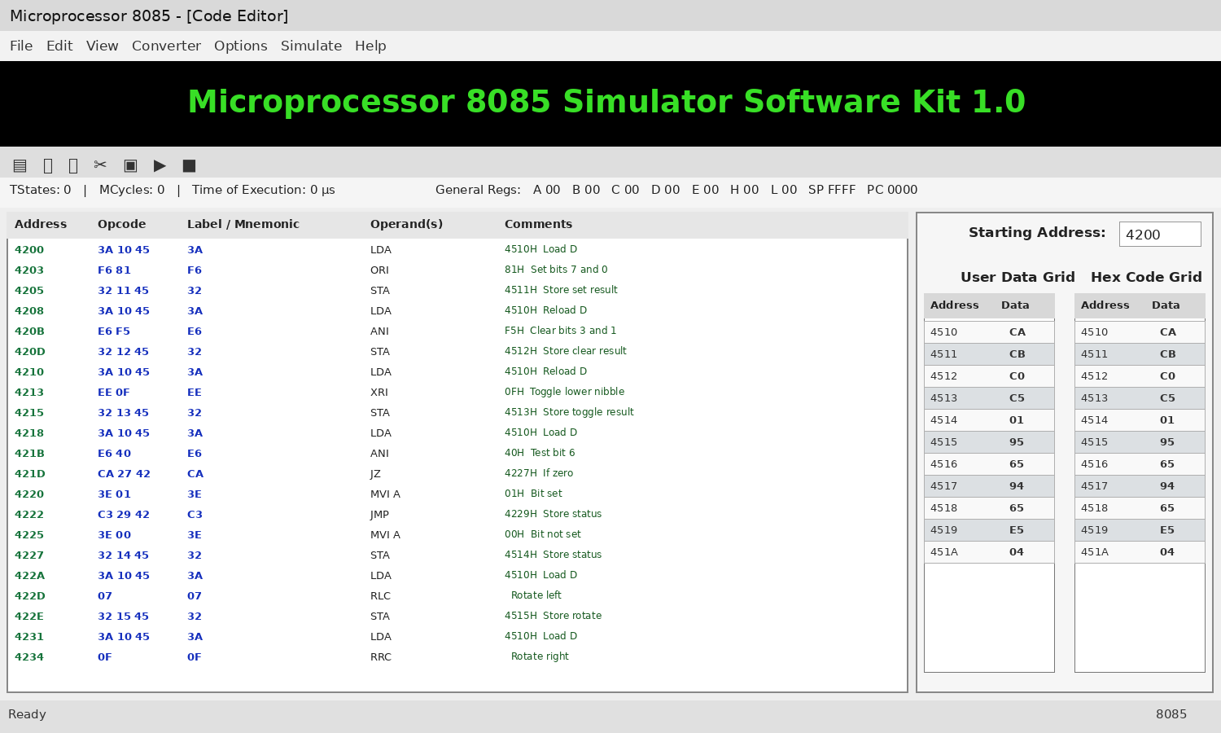
8085 simulator-style screenshot illustration

d. PROGRAM B – 16-BIT LEFT SHIFT
Aim: To write and execute an 8085 assembly language program to perform a 16-bit left shift operation.
Apparatus Required:
- 8085 microprocessor simulator
- Computer system
Input:
- 16-bit number W = 9234H
- Lower byte = 34H at 4520H
- Higher byte = 92H at 4521H
Algorithm:
- Load the 16-bit number into the HL register pair.
- Add the HL register pair to itself using the DAD H instruction.
- The operation shifts the 16-bit value one bit to the left.
- Store the result in the specified memory locations.
- Stop the program.
Program:
LHLD 4520H
DAD H
SHLD 4522H
HLT
Input and Output:
Memory location | Data
4520H | 34H
4521H | 92H
4522H – Result (low byte) | 68H
4523H – Result (high byte) | 24H
Carry flag | 1
Result: Thus, the 16-bit left shift operation was performed successfully using the 8085 microprocessor.

Input: W = 9234H (34H at 4520H, 92H at 4521H).
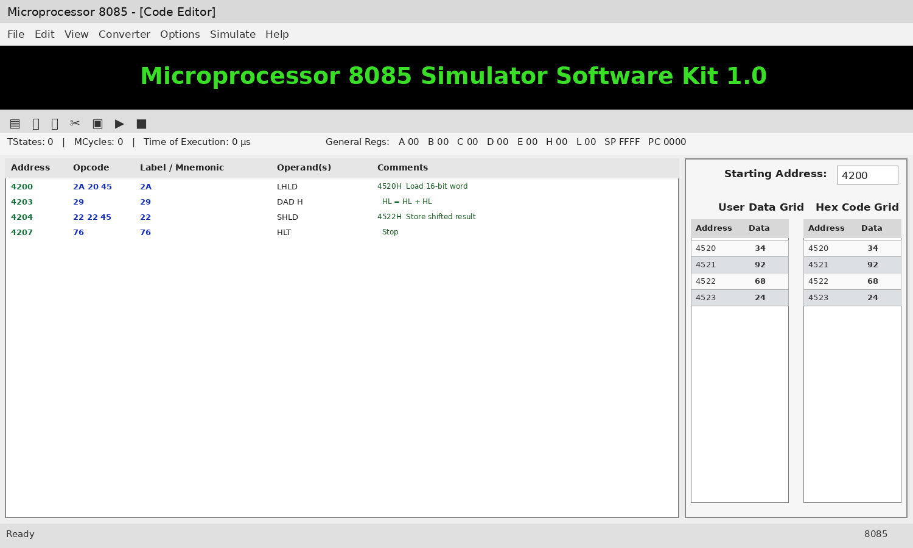
8085 simulator-style screenshot illustration

